Unit 6
RECORDERS, DISPLAYS AND STORAGE DEVICES
- Oscilloscopes:
An Oscilloscope is an electronic test and measurement instrument that graphically displays electrical signals in the form of an X-Y plot. Here, the horizontal (X) represents the time and the vertical (Y) axis represents the magnitude of voltage. So, an Oscilloscope essentially displays a graph of how the voltage of electrical signal changes over time. As a result, earlier Oscilloscopes are called Oscillographs.
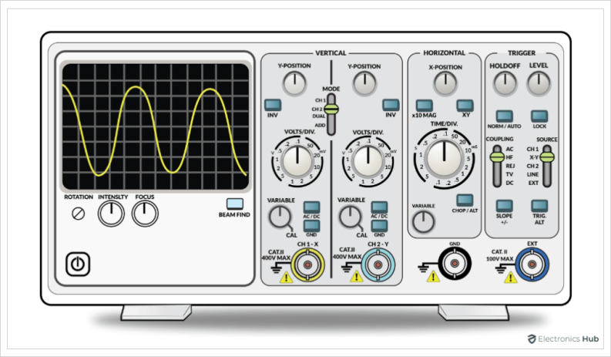
6.1.1 Cathode Ray Tube, Vertical and Horizontal Deflection Systems, Delay Lines, Probes and Transducers.
An oscilloscope is a laboratory instrument commonly used to display and analyze the waveform of electronic signals. In effect, the device drew a graph of the instantaneous signal voltage as a function of time. Engineers are used an oscilloscope to measure phenomena and solve the measurements challenges quickly and accurately to verify their designs or confirm that a sensor is cooking properly. There are three primary oscilloscope systems which are given below.
- Vertical System
- Horizontal System
- Trigger System
All this systems provide information about the electrical signal. So, the oscilloscope can accurately reconstruct it. The oscilloscope block diagram given below;
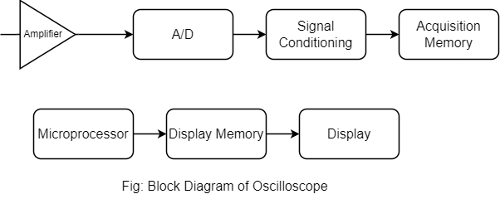
The first stage attenuator or amplifies the signal voltage in order to optimize the amplitude of the signal. This is known as a vertical system since; it depends on the vertical scale control. Where A/D converter used to sample the signal voltage and converted it in a digital format value. The horizontal system, which contains a sample a precise time [Horizontal coordinates] the sample clock drives the A/D converter its digital output is stored in the acquisition memory as records points. The trigger system detects a user-specified condition in the incoming signal stream and applies it as a time reference in the waveform record. The event that met the trigger criteria is displayed.
Block Diagram of Oscilloscope:
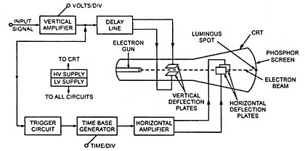
It consists of the following major systems:
- Cathode Ray Tube [CRT]
A cathode ray oscilloscope consists of a cathode ray tube [CRT] which is heart of the oscilloscope and some additional circuitry to operate the CRT, the main part of CRT is;
- Electron Gun Assembly
- Deflection Plate Assembly
- Fluorescent Screen
- Glass Envelope
The electron gun assembly produces a sharply focused beam of electron which accelerated to high velocity. This focused beam of electrons strikes the fluorescent screen with sufficient energy to cause a luminous spot on the screen.
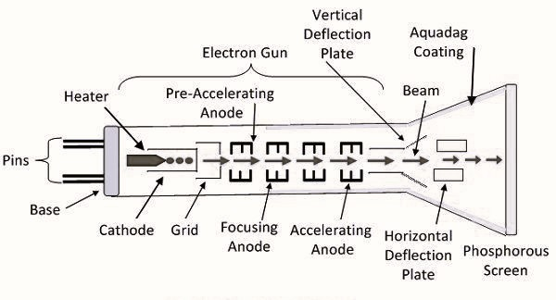
After leaving the electro gun, the electron beam passes through two pairs of electrostatic deflection plates, voltage applied to these plates deflect the beam. Voltage applied to one pair of plates move the beam vertically up and down and the voltage applied to the other pair of plates move the beam horizontally from one side to another. Focusing anode is used to focus the beam on the screen and the accelerating anode makes the electron beam to move with high velocity.
- Vertical Amplifier
The input signal is fed to Y-deflection plate through a vertical amplifier. The function of vertical amplifier is to amplify the input signal. It may consist of several stages in cascade and generally, operates with fixed gain. The output stage of this amplifier is invariably a push-pull amplifier. It is necessary to adjust the magnitude of the input signal so that a large signal may not cause to the display to go out of screen. Therefore, the input signal is fed to the vertical amplifier through an attenuator. The attenuator is a network of resistances and capacitances and it reduces the input signal so that the display of large input signals may not go out of the screen.
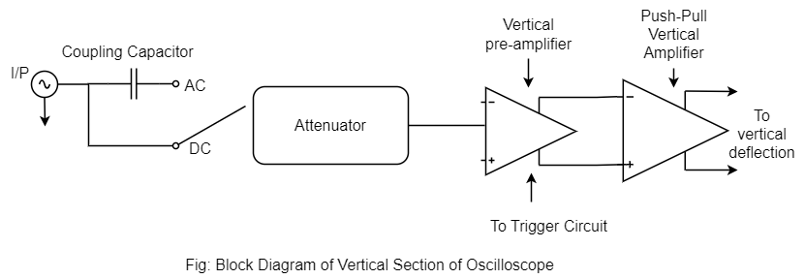
The input converter feeds an input attenuator after which follows the vertical amplifier. The input impedance of an oscilloscope is rather high being on the order of 1MΩ, which is desirable for measuring voltage in might impedance circuit. The attenuator set the sensitivity of the oscilloscope in the common 1-2-5 sequence i.e. the input attenuator could provided 10, 20, 100, 200 mV etc per centimeter. Practically all oscilloscopes provided a switchable input coupling capacitor. This is provided so that measurements of AC signals may be viewed in the presence of high DC voltage by including the coupling capacitor when DC measurements are to be made, the capacitor may remove. The value of the capacitor is chosen so that the frequency response of the entire oscilloscope is preserved down to few hertz.
The vertical amplifier is the principal factor in determining the sensitivity and bandwidth of an oscilloscope. The gain of the vertical amplifier determines the smallest signal that the oscilloscope can satisfactorily reproduce on the CRT screen. The sensitivity of an oscilloscope is directly proportional to gain of the vertical amplifier that is as gain increase sensitivity increased which allows us to observed smaller signal amplified. The vertical sensitivity of an oscilloscope is deflection factor that can be selected with rotary switch. The bandwidth of an oscilloscope is determining the range of frequencies that can be observed by the instruments.
- Horizontal Amplifier
The function of the horizontal amplifier is to be amplifying the signal applied to the X-plate. The amplifier consists of several stages in the cascade. For measurement of voltage and currents the input to the horizontal amplifier is a saw-tooth for frequency and phase measurements, the input is an external signal. The horizontal amplifier should be capable of amplifying both these inputs without distortion.
- Sweep and Time Base Generator
In horizontal deflection plate X-plate is not energized, the electron beam would draw a vertical line on the screen. The function of time base generator is to drive the beam at a steady speed across the screen and when it is reached the right-hand side of the screen, the beam is made to fly back to the starting position on the left-hand side of screen. The time base generator produced the saw-tooth wave which is give below, and then of the same frequency as the input signal to the Y-plate the horizontal deflection of the beam is proportional to the instantaneous voltage of saw-tooth wave. The beam sweeps at a uniform rate across the screen in horizontal direction running to the starting position almost instantaneously and sweeping again.
The time base generator gives an output sweep signal of adjustable frequency. So that the Y-input signals of a wide range of frequency may be displayed on the screen and no needs of external input signal to the X-plates.
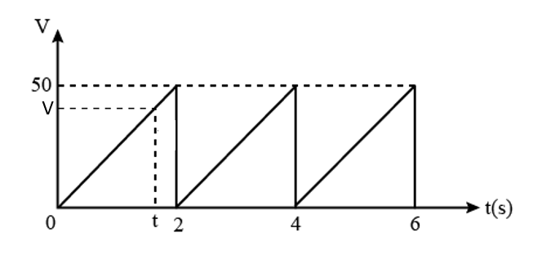
Four type of sweeps;
- Free running sweep
- Triggered sweep
- Driven Sweep
- Now-saw-tooth sweep
- Trigger Circuit
- High and Low Voltage Supply
- Delay Line
It used to delay the signal from some time in vertical section comparing the vertical and horizontal deflection circuit in the oscilloscope block diagram. We observe that the deflection signals is initiated or triggered by a portion of the output signal applied to the vertical CRT plates. Signal processing in the horizontal channel consists of generating and shaping a trigger pulse that starts the sweep generator, whose output is fed to horizontal deflection plate. This whole process takes time on the order of 80ns. To allow the operator to observe the leading edge of the signal waveform, the signal drive for the vertical CRT plates must therefore be delayed by at least the same amount of time. This is function of time delay time.
6.1.2 Specification of an Oscilloscope
- Bandwidth: Probably most important specification of an oscilloscope is its bandwidth. As the frequency of the signal gets closer to the maximum frequency that the oscilloscope can work with its accuracy drops.
- Sample Rate: The sample rate is the number of samples that the oscilloscope is capable of capturing per second. The higher sample rates require more and faster memory to store.
- Memory Size/Depth: Very closely related to the oscilloscope sample rate is its memory size. It stores the waveform data in its memory.
- Rise Time: The rise time of an oscilloscope descries the ability of the instruments to detect and capture rapidly rising and falling signals.
- Channels: Each channels has a separate connector where you can attach a probe and through this probe to monitor a signal. Oscilloscopes have 2 or 4 channels.
- Trigger: The trigger of an oscilloscope is fundamental to its operation. The trigger is the mechanism through which the oscilloscope can recognize a specific attribute of the input signal.
6.1.3 Oscilloscope measurement Techniques
- Voltage Measurement:
Voltage is the amount of electric potential, expressed in volts; usually one of these points is ground zero volts but not always. Voltage can be measured from peak-to-peak i.e. maximum point of a signal to its minimum point.
- Peak to peak value $V_{p-p}=\frac{volts}{div}×no.of div$
- Amplitude $V_{max}=\frac{V_{p-p}}{2}$
- RMS value $V_{rms}=\frac{V_{p-p}}{2\sqrt{2}}$ [For sinusoidal signals only]
- Current Measurement
A CRO has very high input impedance and cannot be used for direct measurements of current; however the current can be measured in term of voltage drop across a std. resistance.
$$I=\frac{V [Measured on CRO]}{R}$$
For measurement of high frequency currents, the shunt should be non-inductive.
- Special Oscilloscope
- Digital Storage Oscilloscope
The digital storage oscilloscope is a superior method of trace storage. In this technique, the waveform to be stored is digitized, stored in a digital memory and retrieved for display on the storage oscilloscope. The stored display can be displayed indefinitely as long as power is applied to the memory which can be supplied to the memory which can be supplied with small battery.
The input is amplitude and attenuated with amplifier. The digital storage oscilloscope uses the same type of input circuitry and oscilloscope probes as conventional oscilloscope and many digital storage oscilloscopes can operates in a conventional mode operates in a conventional mode by-passing the digitizing and storing features. The output of the input signal amplifier feed an A/D converter the main requirement of A/D converter is its speed while accuracy and resolution are of secondary impedance. The digitized output is in the binary form and not BCD form. Generally, successive approximation type of ADC is used in digital storage oscilloscope. Digitizing the analog signal means to take samples of the input signal at periodic interval of time. The sampling rate should be greater than twice the higher frequency present in the input signal so that, sampling theory satisfied. The selection of the sampling rate and memory size depends on the type of waveform being recorded as analog signal is sampled at suitable rates. A continuous storage oscilloscope consists of a feature called pre-trigger view. This indicates that the events that occurred before the trigger input signal was applied are displayed this selection is a percentage selection. This mode is useful when failure occur.
The bloc diagram of a digital storage oscilloscope is given below;
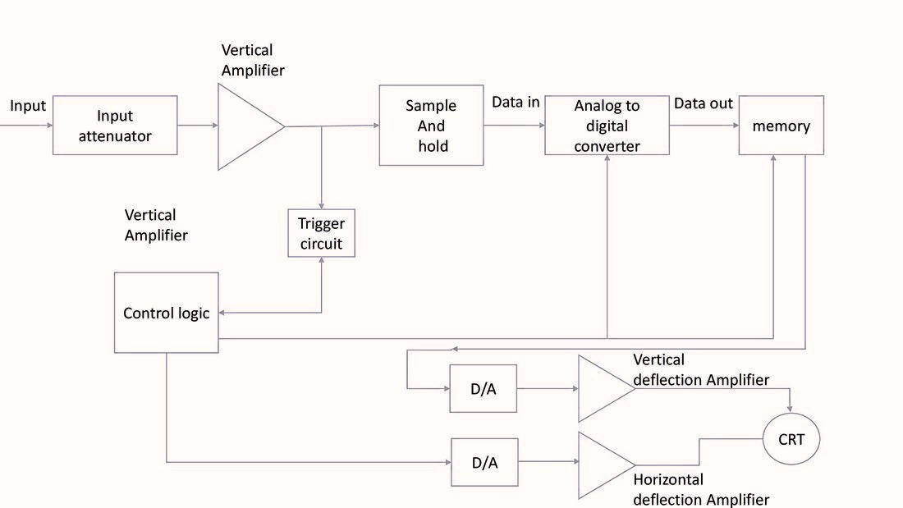
The digital storage oscilloscope has the following three modes of operation;
- Roll mode
- Store mode
- Hold and Save mode
Advantages:
- Infinite storage time
- Easy to operate
- Signal processing is possible
- Cursor measurements is possible
- It is capable of displaying X-Y plots, P-V diagram and B-H curve
Applications:
- It can be used to measure AC as well as DC voltages and currents, Frequency, time period, time interval between two signals etc inductance, capacitance.
- In medical fields, it is used to display cardiogram for diagnosis of heart of patient.
- It is used to observe the radiation pattern generated by transmitting antenna.
- Analyze TV waveform
- It can be used to determine the modulation characteristics and detect the standing waves in transmission lines.
- Sampling Oscilloscope
Sampling technique has to be employed to obtain suitable display and CRO employing such sampling methods are called sampling oscilloscope. The vertical deflection for each dot is obtained from progressively later points in each successive cycles of input waveform as shown figure. The horizontal deflection o the electron beam is obtained by application of stair case waveform to X-deflection plate shown in display of dots.
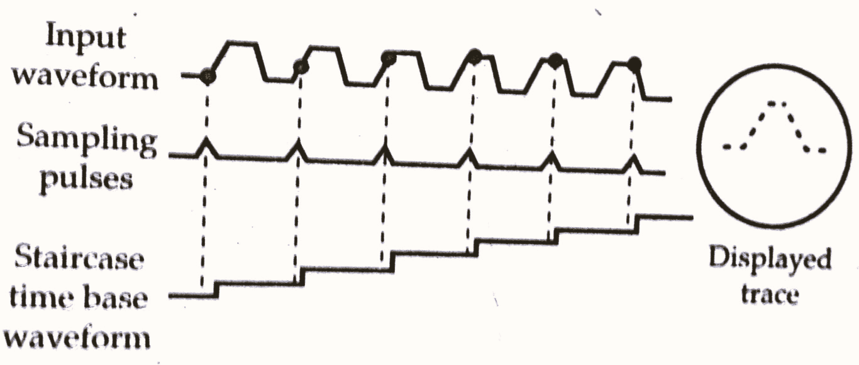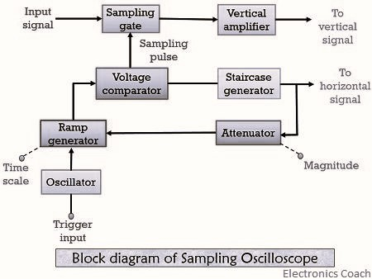
Fig: Sampling Principle and Display of dots
Fig: Block diagram of sampling oscilloscope
The input is applied to the diode sampling gate. As the start of each sampling cycle a trigger input pulse is generated which activates the blocking oscillator. The oscillator output is given to the ramp generator which generates the linear ramp signal, since the sampling must be synchronized with the input signal frequency. The signal is delayed in the vertical amplifier. The staircase generator produced a staircase wave form which is applied to an attenuator. The attenuator controls the magnitude of the staircase signal and then it is applied to a voltage comparator. Another input to the voltage comparator is the output of the ramp generator. The voltage comparator compares the two signals and produces the output pulse when the two voltages are equal. This is nothing but a sampling pulse which applied to sampling gate through the gate control circuitry.
This pulse opens the diode gate and the sample is taken in. This sampled signal is then applied to the vertical amplifier and the Y-deflecting plate. The output of the staircase generator is also applied to the X-deflecting plate. During each step of staircase the spot moves on the screen. The comparator output advances the staircase output through one step. After the certain number of pulses about 100 or so the staircase generator reset. The smallest the size of the steps of the staircase generator, large is the number of sample and higher is the resolution of image. The sampling oscilloscope responds and stores rapid bits information and displays them continuously.
Advantages:
- The display produced is clear.
- High speed electrical signal produced
- Very high frequency performance can be analyzed
- To controlling the size of step of the staircase generator the number of samples and hence the resolution can be controlled.
- The sampling technique allows the design of the oscilloscope with wide bandwidth, high sensitivity, even foe low duty cycle pulses.
Limitations:
- The sampling oscilloscope cannot used to display the transient waveforms.

- Recorders
A recorder records electrical and non-electrical quantities as a function of time. The record may show how one variable varies with respect to another or how the input signal varies with time. The record serves the following objectives;
- It preserves the details of measurements at a particular time.
- It provides at a glance the overall picture of the performance of unit.
- It provides immediate reflection on the action taken by the operator.
Basic recording systems
- Strip Chart recorders
A strip chart consists of following, a long wall of graph paper moving vertically. A system for driving the paper at some selected speed. A stylus for making paper on the moving graph paper [most recorders use a pointer attached to the stylus which pointer moves over a calibrated scale thus showing instantaneous value of the quantity being measured].
A stylus driving system which moves the stylus in nearby exact replica or analog of quantity being measured [A spring wound mechanism may be used but in most of recorders a synchronous motor is used for driving the paper].
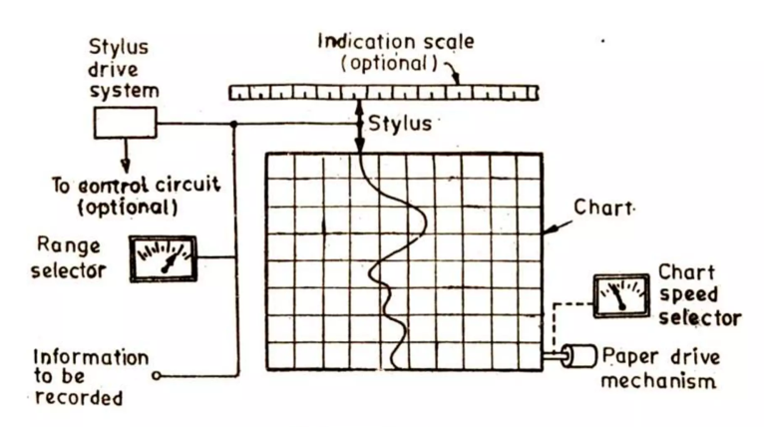
Working Mechanism:
The most commonly used mechanism employed for making marks on the paper is;
- Marking with ink filled stylus
- Marking with heated stylus
- Chopper bar
- Electric Stylus marking
- Electrostatic Stylus
- Optical marking method
Tracing System: For producing graphic representations two types of tracing system are used.
Curvilinear System
Rectilinear System
There are various kinds of strip char recorders, according to working principle here are mainly divided into two categories which are given below:
- Galvanometric Type
This type of recorder operates the deflection principle. The deflection is produced by a galvanometer [D’Arsonval] which produces torque on account of a current passing through its coil. This current is proportional to the quality being measured these recorders can work on ranges for few mA to several mA or from a few mV to several mV. The moving galvanometer type recorder is comparatively inexpensive instruments having narrow bandwidth of 0 to 10 Hz. It has a sensitivity of 0.4mV/mm or from a chart of 100mm width a full scale deflection of 40mV obtained linear amplifier are used for measurement of smaller voltages. This type of recorder is not useful for recordings fast variations in either current or voltage or power.
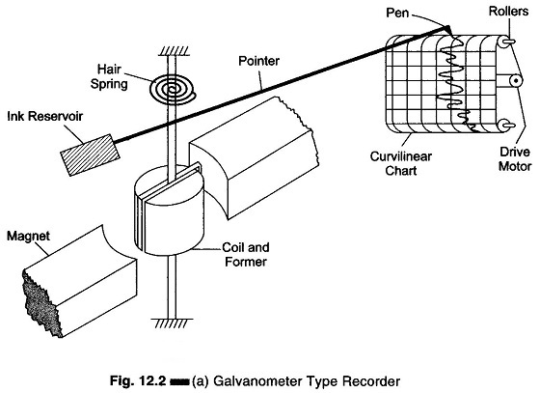
Some recorder contains a timing mechanism that prints a series of small dots along the edge of the paper chart as the paper moves through the recorder. This time marker produces one mark per second. These types of recorders are mostly used as optical recorders, and contain light source provided by either an ultra violet or tungsten lamp. A small mirror is connected to the galvanometer movement and light beam is focused on the mirror. The beam reflected from the mirror is focused into a spot on a light sensitive paper. As the current passes through the coil the mirror deflects. The movement o the light beam is affected by the deflection of the small mirror and the spot on the paper also varies for the same reason thus, tracing the waveform on the paper.
- Potentiometer Type
A Potentiometer recorder is used where input signal to the recorder in a DC voltage. This potentiometer can be converted to recorder by attaching a stylus to the sliding contact. This stylus moves over paper and thus records the quantity under measurements.
During the operation of the recorder, the error signal is amplified and subsequently the field coil of DC motor is energized. The error current either flows in clockwise direction or anticlockwise direction depending on the value of the voltage. The motor turns in such a direction that it reduces error signal to achieve balanced condition. As error signal start reducing the motor shows down and stops completely when error become zero thus, balanced condition is achieved.
The pen which is used for marking waveform is mechanically coupled to a wiper which in turn is mechanically couple to the armature of DC motor thus, when wiper moves according to the error signal. So, the pen also moves in the same direction. As a result, the pen records the input signals variations moving across the paper.
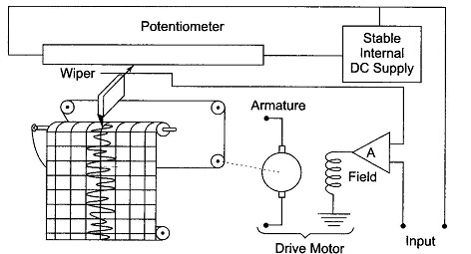
Such recorders have very high input impedance infinity at balance conditions and might sensitivity of the order of 4v/nm with an error of less than ±0.25% with bandwidth of 0.8 Hz.
- Indicators and display Devices-Nixie, LED, LCD and seven segment and dot matrix displays
Nixie Tube: A nixie tube or cold cathode display is an electronic device used for displaying numeral or other discharge. Nixie tubes are display device that were popular in mid of 20th century. They use neon-gas filled tubes with cathodes shaped like numerals or symbols. The tube filled with a gas with low pressure, mostly neon and a small amount of argon, in a penning mixture when voltage is applied, a specific cathode light up, displaying the corresponding character. Nixie tube has a vintage aesthetic and emits a warm orange glow. They are often used in retro-style clocks and other decorative applications.
Its operation does not depend on thermionic emission of electrons from a heated cathode. It is hence a cold-cathode tube and is a variant of the neon lamp. Such tubes rarely exceed 40⁰C [104⁰F] even under the most severe of operating conditions in a room at ambient temperature vacuum fluorescent displays from the same era use completely different technology. They have heated cathode together with a control grid and shaped phosphor anode. Nixie has no heater or control grid, typically a single anode and shaped bare mental cathodes.
- Magnetic tape and disc recorders
Magnetic tape recorders are used for high frequency signal recording. In these recorders, the data is recorded in a way that it can be reproduced in electrical form any time. Also main advantage of these recorders is that the recorded data can be replayed for almost infinite times because of good higher frequency response.
Basic components of tape recorders:
- Recording Head:
The construction of the magnetic recording head is similar to transformer having a toroidal core with coil when the current used for recording i passed through coil wound around magnetic core. It produces magnetic flux when the tape is passing the head, the flux produced due to recording current get linked with iron oxide particle on the magnetic tape and these particle get magnetized.
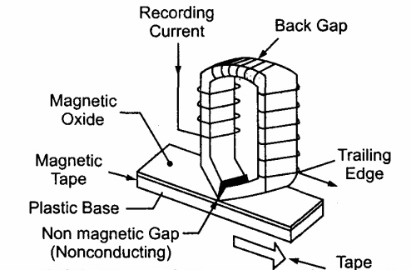
This magnetization particle remains as it is, even through the magnetic tape leaves the gap. The actual recording takes place at the trailing edge of the air gap. Any signal is recorded in the form of the patterns. These magnetic patterns are dispersed anywhere along the length of magnetic tape in recording current with respect to time.
- Magnetic Tape
The magnetic tape is made of thin sheet of tough and dimensionally stable plastic ribbon and wound around a reel. This tape is transferred to one reel to another. When tape passes across air gap magnetic pattern is created in accordance with variation of recording current. To reproduce their pattern, the same tape with some recorded pattern is passed across the magnetic head in which voltage is induced. This voltage included is in accordance with the magnetic pattern.
- Reproducing Head
The use of reproducing head is to get the recorded data played back. The reproducing head detects the magnetic pattern recorded on the tape. The head converts the magnetic pattern back to the original electrical signal. In appearance, both recording and reproducing heads are very much similar.
- Tape Transport Mechanism
The tape transport mechanism moves the magnetic tape along the recording head or reproducing head or reproducing head with constant speed. The magnetic tape is wound on real. There are two reels; one is called as supply other is called as take-up reel. Both the reels rotate in same direction.
The transportation of the tape is done by using supply reel and take-up reel. The fast winding of the tape or the reversing of the tape is done by using special arrangements. The rollers are used to drive and guide the tape.
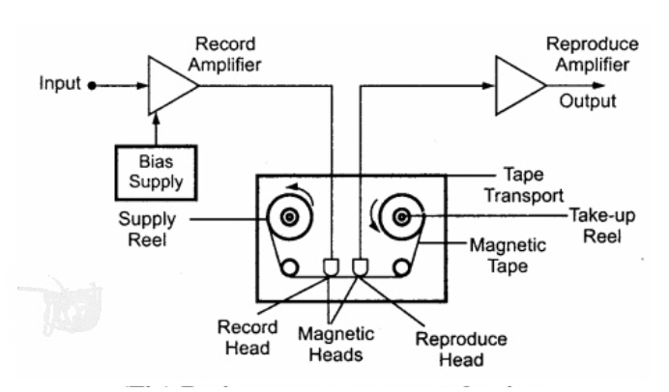
- Conditioning Device
These devices consist of amplifier and filters to modify signal to be recorded.
Principle of Tape Recorders:
When magnetic tape is passing through a recording head, the signal to be recorded appears some magnetic pattern on the tape. This magnetic pattern is in accordance with variation of original recording currents.
The recorded signal can be reproduced back by passing the same tape through a reproducing head where the voltage is induced corresponding to the magnetic pattern on the tape.
When the tape is passed through the reproducing head, detects the changes in the magnetic pattern i.e. magnetization. The change in magnetization of particle produced change in the reluctance of the magnetic circuits of reproducing head, including the voltage in its winding.
The induced voltage depends on the directions of magnetization and its magnitude on the tape. The emf induced is proportional to the rate of change of magnitude of magnetization.
$$e=N\frac{di}{dt}$$
Where, N= Number of turns of winding on reproducing head.
Suppose, signal is recorded is${ V}_{m}\sin{ωt}$. Thus, the current in the recording head and flux induced will be proportional to this voltage. It is given by;
$$e=k_{1}V_{m}\sin{ωt}$$
Where, $k_{1}$= constant.
Above the pattern of flux is recorded on the tape. Now, when this tape is passed through the reproducing head, above pattern is regenerated by inducing voltage in the reproducing voltage in the reproducing head winding. It is given by
$$e=k_{1}UV_{m}\sin{ωt}$$
Thus the reproducing signal is equal to derivative of input signal and it is proportional to flux recorded and frequency of recorded signal.
Applications of Magnetic Tape Recorders:
- Recording of stress, vibration and analysis of noise
- Communication and spying
- Data recording and analysis on missiles, aircraft and satellite.

- Data loggers, Dot matrix and laser printers
Data Logger: It is stand alone device that can record information electronically from internal or external sensors or other equipment that provided digital or serial output.
Features of Data Loggers
- Stand alone operation: Most data loggers are normally configured with a PC, some models can be configured from the front panel provided by the manufacturer. Once the data loggers were configured they don’t need the PC to operate.
- Support for multiple sensor type: Data loggers often have universal type which accepts input from common sensors like thermocouple, RTD, humidity, voltage etc.
- Local data storage: All the data loggers have local data storage and internal memory unit. So, all the measured data storage within the logger for later transfers to PC.
- Automatic Data Collection: Data loggers are designed to collect data at regular interval, 24 hours a day and 365 days a year. If necessary and the collection made is often configurable. Data logging and recording are both analog terms in fields of measurements. Data logging is basically measuring and recording of any physical phenomena or electrical parameter over a period of time. The physical phenomena can be temp; strain, displacement, flow, pressure, voltage, current resistance, power and many parameters etc.
Basic component of data loggers
- Hard components like sensors signal conditioning and A/D converters etc.
- Long term data storage on PC
- Software for collecting data analyzing and viewing.

Dot Matrix:
A dot matrix printer or impact matrix printer refer to a type of computer printer with a print head that runs back and forth on the page and prints by impact, striking an-ink-soaked cloth ribbon against the paper, much like a typewriter. Unlike a typewriter or daisy wheel printer letter are drawn out of a dot matrix varied fonts and arbitrary graphics can be produced.
Because the printing involves mechanical pressure, these printers can create carbon copies and carbon less copies. Each dot is produced by a tiny metal rod also called ‘wire’ or pin which less copies. This is driven forward by the power of a tiny electromagnet or solenoid either directly or through small levers [points]. Facing the ribbon and the paper is a small guide plate pierced with holes to serve as guides for pins. The moving portion of the printer is called the print head and when running the printer as text device it generally prints one line of text at a time.
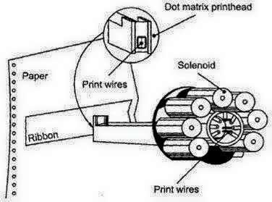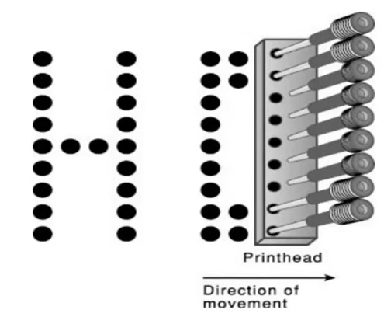
Most dot matrix printers have a single vertical line of dot making equipment on their print heads. Other have a fez interleaved rows in order to improve dot density. Ink invades the guide plate of the print heads causing grit to adhere to it. This grit slowly causes the channels in the guide plate to wear from circles into ovals to slots, providing less and less accurate guidance to the printing wires.
Advantages:
- Can print on multi-part stationary or make carbon copies.
- Impact printer has one of the lowest printing costs per page.
- They are able to use continuous paper rather than requiring individual sheets.
- The ink ribbon also does not easily dry out.
Disadvantages:
- Impact printers are usually noisy.
- They can only low resolution graphics with limited color performance.

Laser Printer
It has a photosensitive drum which is coated with selenium based light sensitive material. The selenium in the dark has a high resistance and consequently becomes changed as it’s passed close to the changing wire; this is a wire at high voltage and off which charge leaks.
A light beam is made to scan along the length of the drum by a small rotating eight-sided mirror. When light strikes the selenium its resistance drops and it can no longer remain charged. By controlling the bright of the beam of light of the beam of light point on the drum can be discharged.
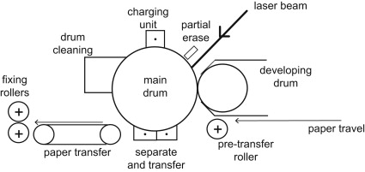
As the drum passé the toner reservoir, the charged area attracts particles of toner which thus stick to the areas that have not been exposed to light and do not stick on the areas that have been exposed to light. The paper is given a charge as it passes another charging wire, called corona wire, so that as it passes close to drum it attracts the toner off the drum. A hot fusing roller is then to melt the toner particles so that after passing between rollers, they finally adhere to paper.
- Compact disc/optical disc recorders
A compact disc is a portable storage medium that can record, store and play back audio, video and other data in digital form. As the results, the signals captured are a replica of the original audio stream. Text, picture images, audio, video and software are all stored on compact discs. It is made up of the three layers.
- Transparent substrate with polycarbonate water [plastic disc] makes up this layer.
- Thin metallic layer coating of aluminum alloy is applied to the water base.
- Outer layer of protective acrylic.
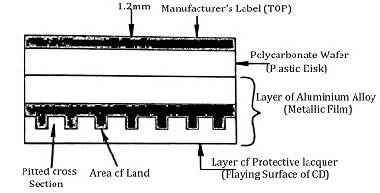
Working Principle:
The using a sample and hold circuit and an ADC the signal to be recorded on CD is first amplified and then transformed into digital signal. The output of the ADC is also used b the laser beam generator. The control circuit and the servo system are both controlled by the signal from the crystals oscillator and laser beam generator.
The servo system, which is controlled by a motor, regulates the disc rotation as well as the track and focus of the laser beam generator. The picture depicts a block schematic of CD recording system. The unexposed photo resist material is chemically removed after leaving a helical pattern across the glass discs surface. This becomes the glass master-production CDs.
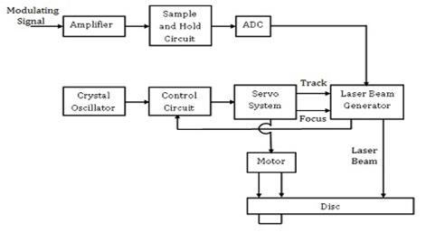
The data retrieval system is made up the phase listed below;
- Servomechanism which spins the CD.
- A laser head that moves in a radial pattern. The laser head can both emit and detect a 70nm laser beam.
When the disc spin, the laser beam is focused into the playing surface, where it is reflected by the lands and scattered by the pits resulting in a change in the quality of high reflected whenever there is a pit-to-land or land-to-pit change. As a result, the pit borders are detected by a laser beam.

